Level 1 -> Level 2

The goal of this level is to find the pass. to log into <http://natas2.natas.labs.overthewire.org>.

Username: natas2

After logging into level 1 we got a hint to get the password of next level. The hint is **“You can find the password for the next level on this page, but right-clicking has been blocked!”**

Again, we need to check the source code, but the right-click is blocked so we need to find out other way to get the source code and hence get the password. Since, I am using chrome browser. I can use Developer tools to inspect the source code of the page.

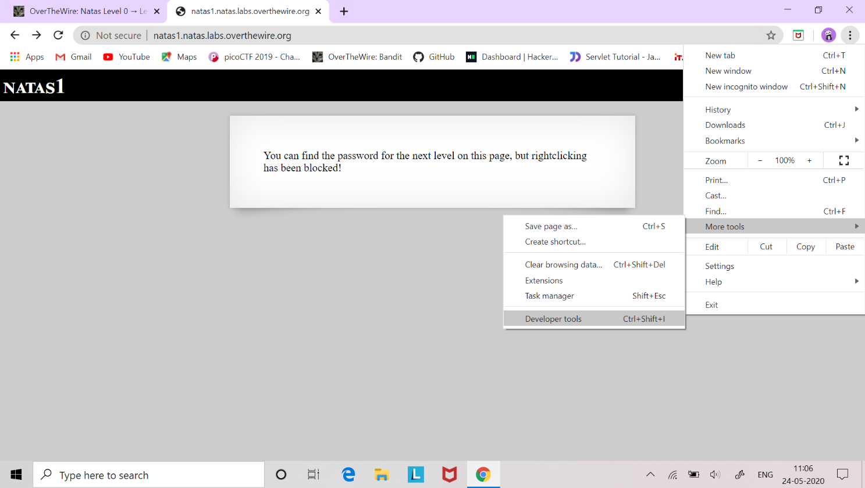

Same as level 1 password is commented in the index file.

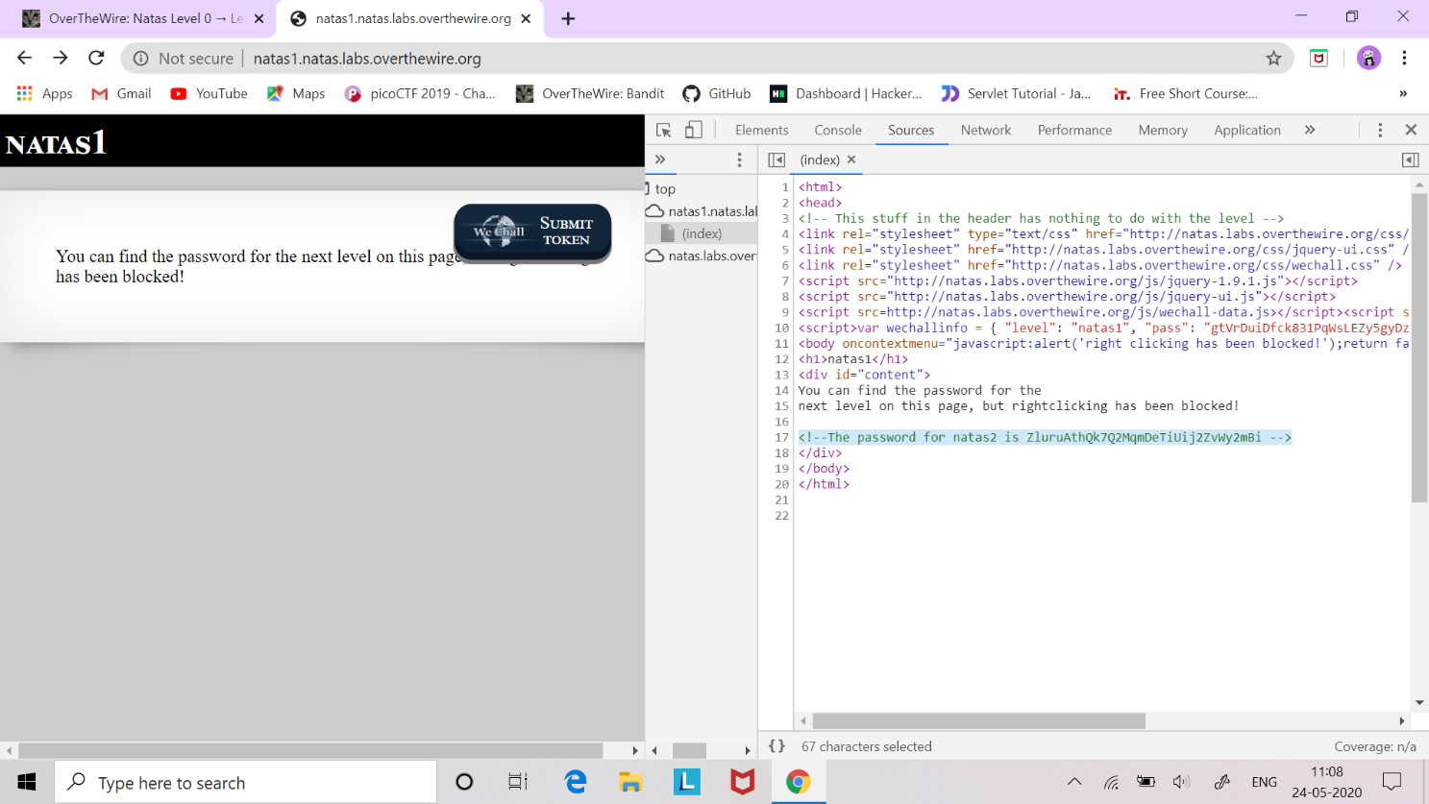

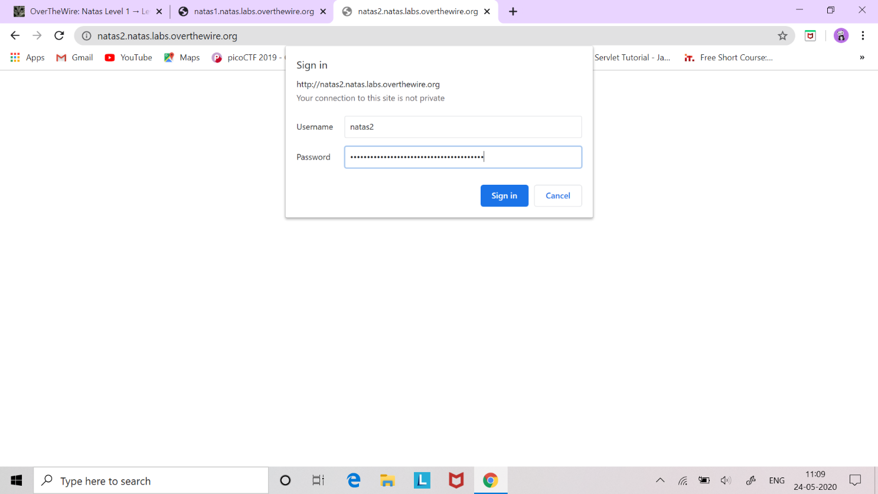

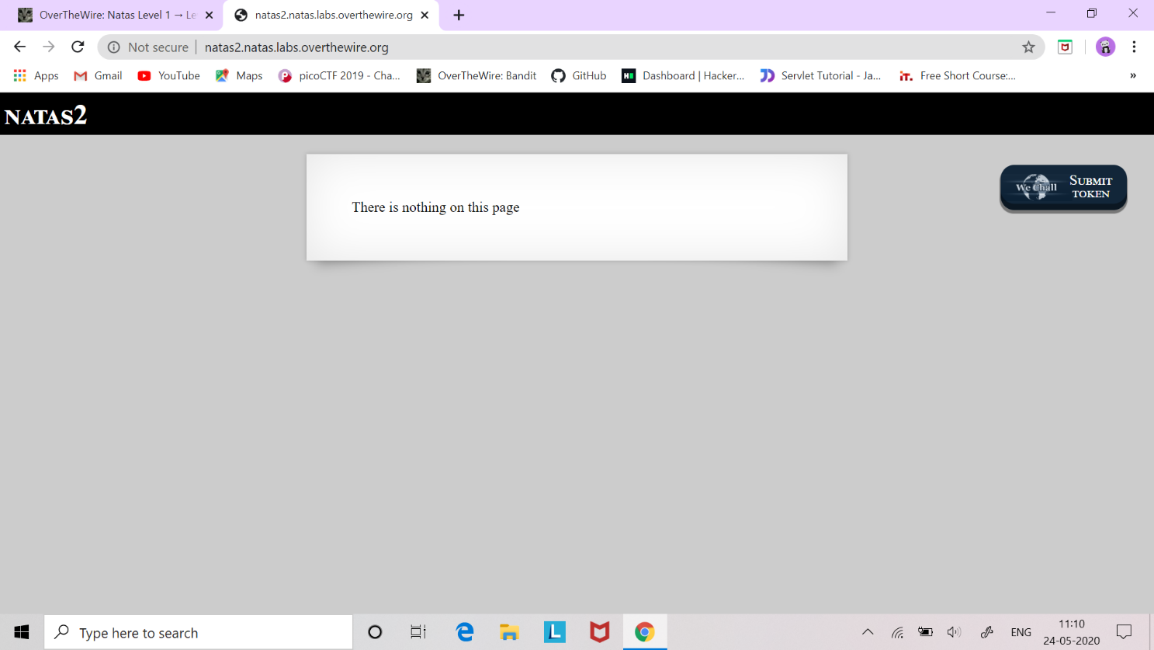

Successfully passed level2.…